Student’s name | …………………………………………………….…… | Grade | 7
Subject | Computer | Quiz No. | 1
Quiz No. ( 1 )

Question A: write the correct name of each part.

Encryption | Plain Text | Algorithm | Cipher Text

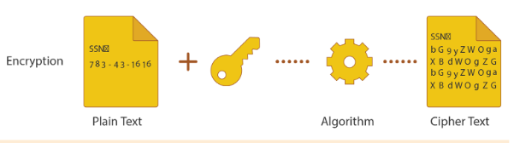
Good Luck
………..…..
……….....
………........
………..

